GHTF/SG5/N7:2012

FINAL DOCUMENT

Global Harmonization Task Force

Title: Clinical Evidence for IVD medical devices – Scientific Validity Determination and Performance Evaluation

Authoring Group: Study Group 5 of the Global Harmonization Task Force

Date: November 2nd, 2012

Dr. Kazunari Asanuma, GHTF Chair

This document was produced by the Global Harmonization Task Force, a voluntary international group of representatives from medical device regulatory authorities and trade associations from Europe, the United States of America (USA), Canada, Japan and Australia.

The document is intended to provide non-binding guidance to regulatory authorities for use in the regulation of medical devices, and has been subject to consultation throughout its development.

There are no restrictions on the reproduction, distribution or use of this document; however, incorporation of this document, in part or in whole, into any other document, or its translation into languages other than English, does not convey or represent an endorsement of any kind by the Global Harmonization Task Force.

Copyright © 2012 by the Global Harmonization Task Force
Table of Contents

1.0 Introduction 4
2.0 Scope 4
3.0 References 5
4.0 Definitions 6
5.0 General Principles of Clinical Evidence 7
6.0 Scientific Validity Determination 10
7.0 Performance Evaluation 11
7.1. Analytical Performance 12
7.2. Clinical Performance 13
7.2.1. Clinical Performance Studies 15
7.2.2. Literature 16
7.2.3. Experience gained by routine diagnostic testing 16
8.0 Clinical Evidence Report 18
Appendices 20

Preface

The document herein was produced by the Global Harmonization Task Force, a voluntary group of representatives from medical device regulatory agencies and the regulated industry. The document is intended to provide non-binding guidance for use in the regulation of medical devices, and has been subject to consultation throughout its development.

There are no restrictions on the reproduction, distribution or use of this document; however, incorporation of this document, in part or in whole, into any other document, or its translation into languages other than English, does not convey or represent an endorsement of any kind by the Global Harmonization Task Force.

Introduction
GHTF would seek to evolve beyond convergence of regulatory requirements to embrace mutual acceptance of common data submissions, pre-market conformity assessment processes, quality systems, quality systems auditing results, and a broad sharing of post-marketing experience. The objective was to allow presentation of data that are acceptable in principle to relevant authorities as the basis for meeting regulatory requirements.

The broad goal for Study Group 5 is to promote the convergence of the regulatory requirements for the generation and presentation of evidence of the clinical safety and performance of medical devices. The Study Group 5 document SG5/N6 recognizes that, in order to progress convergence of regulatory requirements and acceptance of common data, it is necessary to have a common understanding and application of terminology, concepts and principles.

Furthermore, this document was needed to describe the process used to demonstrate clinical evidence and to delineate when the elements of clinical evidence are appropriate for the IVD medical device.

When placing an IVD medical device on the market the manufacturer must have demonstrated through the use of appropriate conformity assessment procedures that the device complies with GHTF’s Essential Principles of Safety and Performance of Medical Devices (EPs). Generally, from a clinical perspective, it is expected that the manufacturer has demonstrated the device achieves its intended performance during normal conditions of use in the intended environment (e.g. laboratories, physician’s offices, healthcare centers, home environments) and in the intended use population. As IVD medical devices are used for the examination of specimens derived from the human body, the characteristics of clinical evidence are different from medical devices other than IVD medical devices.

Scope
The primary purpose of this document is to provide manufacturers with guidance on how to collect and document clinical evidence for an IVD medical device as part of the conformity assessment procedure prior to placing an IVD medical device on the market as well as to support its ongoing marketing. It is also intended to provide guidance to regulators and other stakeholders when assessing clinical evidence provided by manufacturers.

This document provides the following guidance:

- general principles of clinical evidence;
- scientific validity for an analyte, when it is expected to be demonstrated and how to document it;
- analytical performance;
- clinical performance and when it is expected;
- how to demonstrate clinical performance (e.g. studies, literature);
- how to appraise and analyze the data; and
- the content of the clinical evidence report.

The guidance contained within this document applies to devices that meet the definition of an IVD medical device as given in the GHTF document SG1/N71 Definition of the Terms ‘Medical Device’ and ‘In Vitro Diagnostic (IVD) Medical Device.

NOTE: This document should not be used in isolation but read together with the documents ‘Clinical evidence for IVD medical devices – Key Definitions and Concepts’ and ‘Clinical evidence for IVD medical devices –Clinical Performance Studies for In Vitro Diagnostic Medical Devices’ as well as the document ‘Essential Principles of Safety and Performance of Medical Devices’ and the document ‘Summary Technical Documentation (STED) for Demonstrating Conformity to the Essential Principles of Safety and Performance of In Vitro Diagnostic Medical Devices’ (references provided in the reference section).

References
GHTF/SG1/N044:2008 Role of Standards in the Assessment of Medical Devices.

GHTF/SG1/N45:2008 Principles of In Vitro Diagnostic Medical Devices Classification.

GHTF/SG1/N46:2008 Principles of Conformity Assessment for In Vitro Diagnostic Medical Devices.

GHTF/SG1/N63:2011 Summary Technical Documentation (STED) for Demonstrating Conformity to the Essential Principles of Safety and Performance of In Vitro Diagnostic Medical Devices.

GHTF/SG1/N68:2012 Essential Principles of Safety and Performance of Medical Devices.

GHTF/SG5/N6:2012 Clinical Evidence for IVD medical devices – Key Definitions and Concepts.

GHTF/SG5/N8:2012 Clinical evidence for IVD medical devices – Clinical Performance Studies for In Vitro Diagnostic Medical Devices.

Definitions
Diagnostic sensitivity (Clinical sensitivity)
Ability of an IVD medical device to identify the presence of a target marker associated with a particular disease or condition.
NOTE 1: Also defined as percent positivity in samples from subjects where the target disease or condition is known to be present.
NOTE 2: Diagnostic sensitivity is a number fraction, calculated as true positive values divided by the sum of true positive plus false negative values.
NOTE 3: The disease or condition is defined by criteria independent of the IVD medical device under consideration.
Source: ISO 18113-1:2009 modified.

Diagnostic specificity (Clinical Specificity)
Ability of an IVD medical device to recognize the absence of a target marker associated with a particular disease or condition.
NOTE 1: Also defined as percent negativity in samples where the target analyte (measurand) is known to be absent.
NOTE 2: Diagnostic specificity is a number fraction, calculated as true negative values divided by the sum of true negative plus false positive values.
NOTE 3: The disease or condition is defined by criteria independent of the medical device under consideration.
Source: ISO 18113-1:2009 modified.

Examination
Set of operations having the object of determining the value or characteristics of a property.

NOTE 1: In some disciplines (e.g., microbiology) an examination is the total activity of a number of tests, observations or measurements.
NOTE 2: Laboratory examinations that determine the value of a property are called quantitative examinations; those that determine the characteristics of a property are called qualitative examinations.
NOTE 3: Laboratory examinations are also called ‘assays’ or ‘tests.’
Source: ISO 18113-1:2009 modified

IVD medical device
Refer to GHTF/SG1/N71:2012 Definition of the Terms ‘Medical Device’ and ‘In Vitro Diagnostic (IVD) Medical Device’.

Predictive value
Probability that a person with a positive IVD medical device test result has a given condition under investigation, or that a person with a negative IVD medical device test result does not have a given condition.

NOTE 1: The predictive value is determined by the diagnostic sensitivity and diagnostic specificity of the IVD medical device test procedure, and by the prevalence of the condition for which the examination is used.
NOTE 2: Prevalence means the proportion of persons with a particular disease within a given population at a given time.
NOTE 3: The positive predictive value indicates how effectively an IVD medical device separates true positive test results from false positive test results for a given attribute in a given population.
NOTE 4: The negative predictive value indicates how effectively an IVD medical device separates true negative test results from false negative test results for a given attribute in a given population.
Source: ISO 18113-1:2009 modified

Recognized Standards
Standards deemed to offer the presumption of conformity to specific Essential Principles of Safety and Performance.

GHTF SG1/N044:2008 Role of Standards in the Assessment of Medical Devices.

Technical Documentation
The documented evidence, normally an output of the quality management system, that demonstrates compliance of a device to the Essential Principles of Safety and Performance of Medical Devices (SG1/N041).

GHTF SG1/N046:2008 Principles of Conformity Assessment for IVD Medical Devices.

General Principles of Clinical Evidence
To understand clinical evidence for IVD medical devices it must be taken into account that IVD medical devices differ from other medical devices in that the risks and benefits they pose are related to impact on patient management rather than direct contact between the device and the patient. A significant percentage of all healthcare decisions rely on information provided by clinical laboratory tests and these decisions can profoundly influence diagnosis and management of the patient.

Clinical evidence requirements will be influenced by the risk to the patient of an incorrect result from the IVD medical device, the degree of innovation reflected in the scientific/clinical recognition of the analyte of interest, the assay technology, the novelty, the degree of variability of the subject population and disease state, and the intended user(s) of the device. While not intended to impose unnecessary burdens, clinical evidence must support the intended use of the IVD medical device as stated by the manufacturer while addressing the relative risks to the patient associated with the use of the device.

Gathering of information to support clinical evidence starts at the research phase for IVD medical devices and this process consists of two major phases: the identification of the scientific validity of the analyte and the performance evaluation of the specific IVD medical device.

Once the scientific validity of an analyte is identified, the design process may lead to the development of an IVD medical device or a design change to an existing IVD medical device. The design process will be supported by a performance evaluation.

For IVD medical devices that have a new intended use, the existing clinical evidence report should be assessed as to its suitability to support the new intended use. If the new intended use is not supported by the existing evidence, then additions to the scientific validity, the analytical performance, and where appropriate, the clinical performance should be considered.

The generation and assessment of clinical evidence is an ongoing process. Information related to clinical evidence should be monitored routinely by the manufacturer once the IVD medical device is available on the market. Additional post-marketing information (e.g. adverse event reports, results from performance studies, published literature) should be reviewed as needed to determine possible impact on benefits and risks of the IVD medical device.

Stages of clinical evidence
Figure 1 on the next page provides an overview of the stages involved in the assessment of clinical evidence.

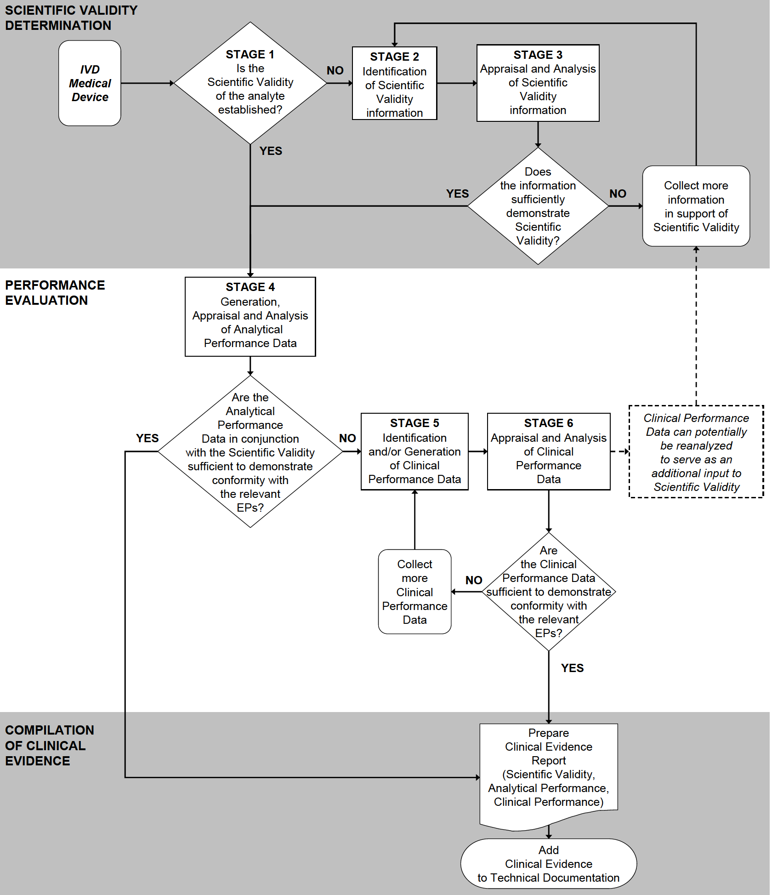
Figure 1: Stages of the Clinical Evidence Assessment Process

Scientific Validity Determination
Stage 1 - Is the scientific validity of the analyte established?

Determination of scientific validity is not necessary where association of an analyte to a clinical condition/physiological state is well known, based on available information such as peer reviewed literature, textbooks, historical data and experience. For example it would not be reasonable to expect a manufacturer to demonstrate haemoglobin is associated with anaemia given the well established and recognized association. If the scientific validity is established, a brief rationale should be documented in the final clinical evidence report (e.g. a brief list of key references). Proceed to Stage 4.

For a new analyte and/or new intended use, scientific validity needs to be demonstrated. Proceed to Stage 2.

Stage 2 – Identification of scientific validity of the analyte

Potential sources for the identification of scientific validity information are:

- Information on IVD medical devices that measure the same analyte and with the same intended use that have marketing history (e.g. Instructions for Use)
- Literature searching: this information might be found in peer reviewed articles, regulatory guidance documents, conference proceedings, etc.
- Review of expert opinions: this information might be found in sources that include textbooks, clinical guidance documents, position statements from academic and professional organizations.
- Results from proof of concept studies: these studies are usually smaller scale scientific studies to identify the fundamental association of the analyte with the clinical condition/physiological state.
- Results from clinical performance studies

Scientific validity will be based on one or more of these potential information sources.

Stage 3 – Appraisal and analysis of scientific validity information

The purpose of the scientific validity appraisal is to select information based on its merits and limitations. Each piece of information is appraised to determine its relevance and quality for establishing the association between the analyte and the clinical condition/physiological state.

To be relevant the information source should reference both the analyte and the clinical condition/physiological state in question, and should show a clear link between the two.

The information provided should be of sufficient quality to enable a rational and objective assessment of the scientific validity.

The scientific validity analysis aims to collectively evaluate all of the appraised information, in terms of weight and significance.

The outcome of the analysis should include references, justifications and conclusions supporting a valid association between the analyte and the clinical condition/physiological state.

The scientific validity should be summarised as part of the clinical evidence report.

Performance Evaluation
Performance evaluation for an IVD medical device is the process by which data are assessed and analyzed to demonstrate the performance (analytical performance and, where applicable, clinical performance) of the envisioned IVD medical device for the intended use as stated by the manufacturer.
To address the appropriate requirements for performance evaluation, IVD medical devices may be segregated into three different categories:

a) Established and standardized tests
These tests have clinical guidelines or consensus for the use of the test, there is more than one commercial test available, and/or international standard or reference materials exist. These tests produce comparable results for the analyte regardless of the method or the manufacturer.

Examples of this category include tests for liver markers (e.g. AST, ALT, bilirubin), kidney markers (e.g. creatinine, BUN), electrolytes (e.g. sodium, chloride), metabolic markers (e.g. glucose, calcium, albumin, total protein), hormones (e.g. hCG), blood gases, and biochemical tests for the identification of microorganisms.

b) Established and non standardized tests
These tests have clinical guidelines or consensus for the use of the test, and there is more than one commercial test available. While international reference materials may exist, results obtained from different IVD medical devices might not be used interchangeably.

Examples of this category include tests for infectious diseases (e.g. Rubella, Hepatitis C), hormones (e.g. estradiol), cardiac markers (e.g. troponin), tumour markers (e.g. BCR-ABL, CEA, PSA), and cell markers (e.g. CD4, T-cells).

c) Novel tests
Such tests involve a new analyte, new technology, new target population, new application of an established technology, or a new intended use, and they are not established or standardized.

Examples of this category include tests for newly identified cardiac markers (e.g. high sensitivity CRP) and tumour markers (e.g. CTC), pharmacogenomics (e.g. CCR5), emerging infectious diseases (e.g. SARS, H1N1) and other pathogens (e.g. vCJD).

NOTE: New technology is defined as the practical application of a new technical process to measure an existing biological marker. Examples include:
- DNA amplification as a new technology for blood typing (previously agglutination)
- immunoassay as a new technology for immunosuppressive drug monitoring (previously mass spectroscopy).
- progression of technologies for diagnosis of cystic fibrosis (from Restriction Fragment Length Polymorphisms (RFLP) to sequencing to SNP genotyping to advanced PCR techniques).

Analytical Performance
Stage 4 – Generation, appraisal and analysis of analytical performance data

Analytical performance studies are always expected for each IVD medical device.

Analytical performance, which refers to technical test performance, may include data to demonstrate accuracy (derived from trueness and precision), analytical sensitivity (e.g. limit of detection, limit of quantitation) , analytical specificity, linearity, cut-off, measuring interval (range), carry-over, as well as determination of appropriate specimen collection and handling, and endogenous and exogenous interference on assay results. For more details refer to GHTF/SG1/N63:2011 Summary Technical Documentation (STED) for Demonstrating Conformity to the Essential Principles of Safety and Performance of In Vitro Diagnostic Medical Devices.

It should be noted that analytical studies for trueness are usually based on one or more of the following:

a) methods described in a recognized standard (e.g. ISO 15197: In vitro diagnostic test systems – Requirements for blood-glucose monitoring systems for self-testing in managing diabetes mellitus)
b) comparison with an international reference method (e.g. atomic absorption for calcium)
c) comparison with a reference material of a higher order (e.g. international reference materials)

Where the above described methods are not readily available, it may be possible to perform a comparison with an already available IVD medical device (e.g. method comparison between immunoassays) or a comparison to a recognized method, (e.g. Sanger sequencing for genotyping assays).

For novel tests, it may not be possible to demonstrate trueness since recognized reference materials or a suitable comparative method are not likely to be available. If there are no comparative methods then different approaches can be used (e.g. comparison to some other well-documented method, comparison to the composite reference method).
In the absence of such approaches, a clinical performance study comparing test performance to the current clinical standard practice would be needed.

In most circumstances, analytical performance testing using human specimens is needed. If specimens are of limited availability or do not cover the desired range of the assay or presence of the analyte (measurand), the use of contrived samples (e.g. spiked) may be acceptable with appropriate justification.

For the purpose of reviewing clinical evidence for the IVD medical device in question, an assessment needs to be made whether the analytical performance data in conjunction with the scientific validity is sufficient to declare conformity with relevant EPs.

For an established and standardized test, information about analytical performance in conjunction with scientific validity information meets the clinical evidence requirements and is sufficient to demonstrate conformity with relevant EPs.

For an established and non-standardized test, information about analytical performance in conjunction with scientific validity information alone may not meet the clinical evidence requirements and may not be sufficient to demonstrate conformity with relevant EPs.

For a novel test, information about analytical performance in conjunction with scientific validity information alone most likely will not meet the clinical evidence requirements and most likely will not be sufficient to demonstrate conformity with relevant EPs

The analytical performance data should be summarised as part of the clinical evidence report.

Clinical Performance
Clinical performance of the IVD medical device is the relationship between the testing results and the clinical conditions of patients.
The clinical performance of an IVD medical device may be characterised by:
- diagnostic specificity, which indicates the effectiveness of an IVD medical device in correctly classifying patients that do not have a particular disease or condition, and
- diagnostic sensitivity, which indicates the effectiveness of an IVD medical device in correctly identifying patients who have a particular disease or condition.
- positive predictive value, which indicates the effectiveness of an IVD medical device in separating true positive results from false positive results for a given attribute in a given population.
- negative predictive value, which indicates the effectiveness of an IVD medical device in separating true negative results from false negative results for a given attribute in a given population.
- likelihood ratio, which refers to the likelihood that a given result would be expected in an individual with the target clinical condition/physiological state compared to the likelihood that the same result would be expected in an individual without that clinical condition/physiological state.
- expected values in normal and affected populations.

NOTE: The diagnostic sensitivity and diagnostic specificity depend on the choice of a cut-off value (e.g. to separate negative from positive values).

NOTE: Predictive value depends on the prevalence of the disease or condition in the population of interest.

The need for clinical performance will depend on the test:
- For an established and standardized test, clinical performance will not be required to demonstrate conformity with relevant EPs.
- For an established and non-standardized test, clinical performance will often be required to demonstrate conformity with relevant EPs.
- For a novel test, clinical performance most likely will be required to demonstrate conformity with relevant EPs.

In addition to the above situations clinical performance would not be expected for situations such as:
- Assay migration of the same reagents, between instruments that share the same basic analytical technology, but may for example vary in instrument throughput, whereby the formulation and the intended use of the assay do not change. There should be no expected change in clinical performance of the assay when run on the new instrument.
- Class A IVD medical devices.

The clinical performance data should be summarised as part of the clinical evidence report.

Stage 5 - Identification of clinical performance
Manufacturers are able to draw on one or more data sources to demonstrate clinical performance.

Potential sources for the identification of clinical performance data:
- Clinical Performance Studies
- Literature
- Experience gained by routine diagnostic testing

Data relevant to the clinical performance may be held by the manufacturer (e.g. manufacturer sponsored pre and post-market study reports and adverse event reports for the IVD medical device in question) or in the scientific literature (e.g. published articles of clinical performance studies for the IVD medical device).

The manufacturer is responsible for identifying data relevant to the IVD medical device and determining the types and amount of data needed to establish clinical performance, giving consideration to the advantages and limitations of each data type.

Clinical Performance Studies
The guidance included within this section applies to clinical performance studies carried out by or on behalf of a manufacturer specifically for the purposes of conformity assessment in accordance with applicable regulations. Such studies are generally expected to be designed, conducted and reported in accordance and in compliance with local regulations and guidance.

Clinical performance studies should be designed, conducted, analyzed and evaluated so that the best possible representation is achieved with the target population in accordance with the intended use. Optimal clinical evaluation design, execution and analysis will ensure the greatest possible generalization of results (e.g. for different demographic or ethnic groups, multiple sites in different health care and geographical settings).

When conducting a performance study to establish the clinical performance of an IVD medical device, testing is usually performed in parallel to the routine diagnostic testing performed for patient management care. In these cases, patient management decisions are based on the routine standard test.

There should be careful selection of the routine diagnostic test(s) which will be used as the comparative method to evaluate the performance of an IVD medical device. Where possible, a reference test method should be included in the performance study protocol, and qualified with appropriate reference to the literature.

The design of clinical performance studies must reflect the nature of the IVD medical device and its intended use. Further explanation of clinical performance study design is discussed in SG5/N8 Clinical evidence for IVD medical devices – Clinical Performance Studies for In Vitro Diagnostic Medical Devices.

While not intended to impose unnecessary burdens, the clinical performance studies must provide evidence to support the intended use of the IVD medical device while addressing the relative risks/benefits associated with the use of the IVD medical device.
NOTE: Testing performed pre-market that is not designed to address clinical performance of an IVD medical device is not considered a clinical performance study (examples of such studies are customer feedback studies, external analytical performance studies, research studies).

Literature
Literature searching can be used to identify published clinical performance data that is not in the possession of the manufacturer that may assist the manufacturer in establishing acceptable clinical performance of an IVD medical device. The data generated through literature searching should relate directly to the IVD medical device in question or earlier versions with justification as to why the data for the earlier versions are applicable (e.g. reports of clinical studies that have been performed by third parties).

When conducting a literature review, a comprehensive search should be conducted. For further guidance, refer to Appendices A and B.

Once the literature search has been executed, a summary should be prepared and included in the clinical performance evaluation report. A copy of the methodology (e.g. databases, search terminology) should be included and any deviations noted. It is important that the literature search is documented in sufficient detail so that the methods can be appraised critically, the results can be verified, and the search reproduced if necessary.

It is recognised that in cases where manufacturers source clinical performance data reported in the scientific literature (i.e. studies of the IVD medical device in question undertaken by a third party); the documentation readily available to the manufacturer for inclusion in the clinical evidence report is likely to be no more than the published paper itself.

Experience gained by routine diagnostic testing
These types of performance data are generated in actual use conditions that are outside the conduct of clinical performance studies. While much of the experience with routine diagnostic testing is found in literature, additional data may include:

- manufacturer-generated post-market surveillance data (e.g. customer testing results)
- adverse events databases (held by either the manufacturer or Regulatory Authorities)
- data for the device in question generated from individual patients under emergency (e.g. test for H1N1 in 2009) prior to marketing of the IVD medical device
- details of clinically relevant field safety corrective actions (e.g. recalls, notifications, hazard alerts)

The value of routine diagnostic testing experience data is that it provides real world experience obtained in larger, heterogeneous and more complex populations (e.g. with regard to interfering substances). The data are most useful for identifying less common but potentially serious device-related adverse events. It is also a particularly useful source of diagnostic testing data for low risk devices that are based on long standing, well-characterized technology and, therefore, unlikely to be the subject of either reporting in the scientific literature or performance study.

The analyses of post-marketing data may, for some IVD medical devices, provide reasonable assurance of performance. However, for higher risk IVD medical devices, data from routine diagnostic testing alone would rarely be sufficient to demonstrate clinical performance.

If a manufacturer chooses to use experience data from routine diagnostic testing, it is important that any reports or collations of data contain sufficient information to be able to undertake a rational and objective assessment of the information and make a conclusion about its significance with respect to the performance of the IVD medical device in question. Reports of such experience that are not adequately supported by data, such as anecdotal reports or opinion, should not be used.

Stage 6 – Appraisal and analysis of clinical performance data

The purpose of the clinical performance appraisal is to select information based on its merits and limitations. Each piece of information is appraised to determine its relevance and quality to address questions about the IVD medical device, and its contribution to demonstrate the clinical performance of the IVD medical device (including any specific claims about performance).

To be relevant the information source should be specific to the IVD medical device in question and reflect its intended use.

The information provided should be of sufficient quality to enable a rational and objective assessment of the clinical performance.

The clinical performance analysis aims to collectively evaluate all of the appraised information, in terms of weight and significance. For the purpose of Clinical Performance evaluation, clinical performance study data is typically weighted higher than literature data which in turn is generally weighted higher than data gathered from routine diagnostic testing.

When weighting the results, particular attention should be given to circumstances where there are repeated publications on the same group of patients by the same authors, in order to avoid over-weighting the experience.

The different data sets should be reviewed for consistency of results across multiple sites and as appropriate, the intended target populations.

If the different data sets report comparable performance characteristics, certainty about the clinical performance increases. If different results are observed across the data sets, it will be helpful to determine the reason for such differences. Regardless, all data sets should be included.

As a final step, the evaluator should consider the basis on which it can be demonstrated that the combined data show:
- the IVD medical device performs as intended by the manufacturer; and
- any risks associated with the use of the IVD medical device are acceptable when weighed against the benefits to the patient.

Such considerations should take into account:
- the intended users
- the number and severity of adverse events
- the adequacy of the estimation of associated risk for each identified hazard
- the severity and natural history of the condition being diagnosed or treated
- the availability of alternative diagnostic tests and current standard of care

The outcome of the analysis should be summarised in a report comprising references, justifications and conclusions regarding the clinical performance of the IVD medical device.

The instructions for use should be reviewed to ensure they are consistent with the data and that all the hazards and other clinically relevant information have been identified appropriately.

Clinical Evidence Report
The clinical evidence report is a compilation of the scientific validity, analytical and clinical performance. If the analytical performance data is determined to be sufficient to declare conformity with the relevant Essential Principles without the need for clinical performance data, a brief rationale should be documented and included in the report. If the manufacturer concludes there is insufficient clinical evidence to be able to declare conformity with the Essential Principles, the manufacturer will need to generate additional data (e.g. conduct a clinical performance study, broaden the scope of literature searching) to address the deficiency. In this respect, development of clinical evidence, and in particular, clinical performance, should be an iterative process.

The clinical evidence report may reference or be a compilation of the information related to scientific validity, analytical performance and, where applicable, clinical performance. It is important that the report outline:
- the justification for the overall approach taken to gather the clinical evidence;
- the technology on which the medical device is based, the intended use of the device and any claims made about the device’s clinical performance or safety;
- the nature and extent of the scientific validity and the performance data that has been evaluated;
- how the referenced information (recognised standards and/or clinical data) demonstrate the clinical performance and safety of the device in question; and
- the literature search methodology, if a literature review is the approach taken to gathering clinical evidence.

It should be noted that the level of detail in the report content will vary according to the risk class of the IVD medical device and its intended use.

Appendices
Appendix A: Possible Format for the Literature Search Report

1. Device name/model
2. Scope of the literature search [should be consistent with the scope of the scientific validity and/or clinical performance]
3. Methods
(i) Date of search
(ii) Name of person(s) undertaking the literature search
(iii) Period covered by search
(iv) Literature sources used to identify data
- scientific databases – bibliographic (e.g. MEDLINE, EMBASE);
- specialized databases (e.g. MEDION)
- systematic review databases (e.g. Cochrane Collaboration);
- clinical trial registers (e.g. CENTRAL, NIH);
- adverse event report databases (e.g. MAUDE, IRIS)
- reference texts
[Include justification for choice of sources and describe any supplemental strategies (e.g. checking bibliography of articles retrieved, hand searching of literature) used to enhance the sensitivity of the search]
(v) Database search details
- search terms (key words, indexing headings) and their relationships (Boolean logic)
- medium used (e.g. online, CD-ROM (including publication date and edition))[Attach copy of downloaded, unedited search strategy]
(vi) Selection criteria used to choose articles
4. Outputs
(i) Attach copy of literature citations retrieved from each database search
(ii) Data selection process
[Attach flow chart and associated tables showing how all citations were assessed for suitability for inclusion in the clinical evidence (see Appendix B)]
NOTES:
EMBASE Excerpta Medica published by Elsevier
CENTRAL The Cochrane Central Register of Controlled Trials
IRIS The TGA’s medical device Incident Report Investigation Scheme
MAUDE US FDA’s Manufacturer And User Facility Device Experience database
Appendix B: Possible Methodology for Documenting and the Screening and Selection of Literature within a Literature Search Report
POSSIBLE METHODOLOGY FOR SCREENING AND DOCUMENTING LITERATURE
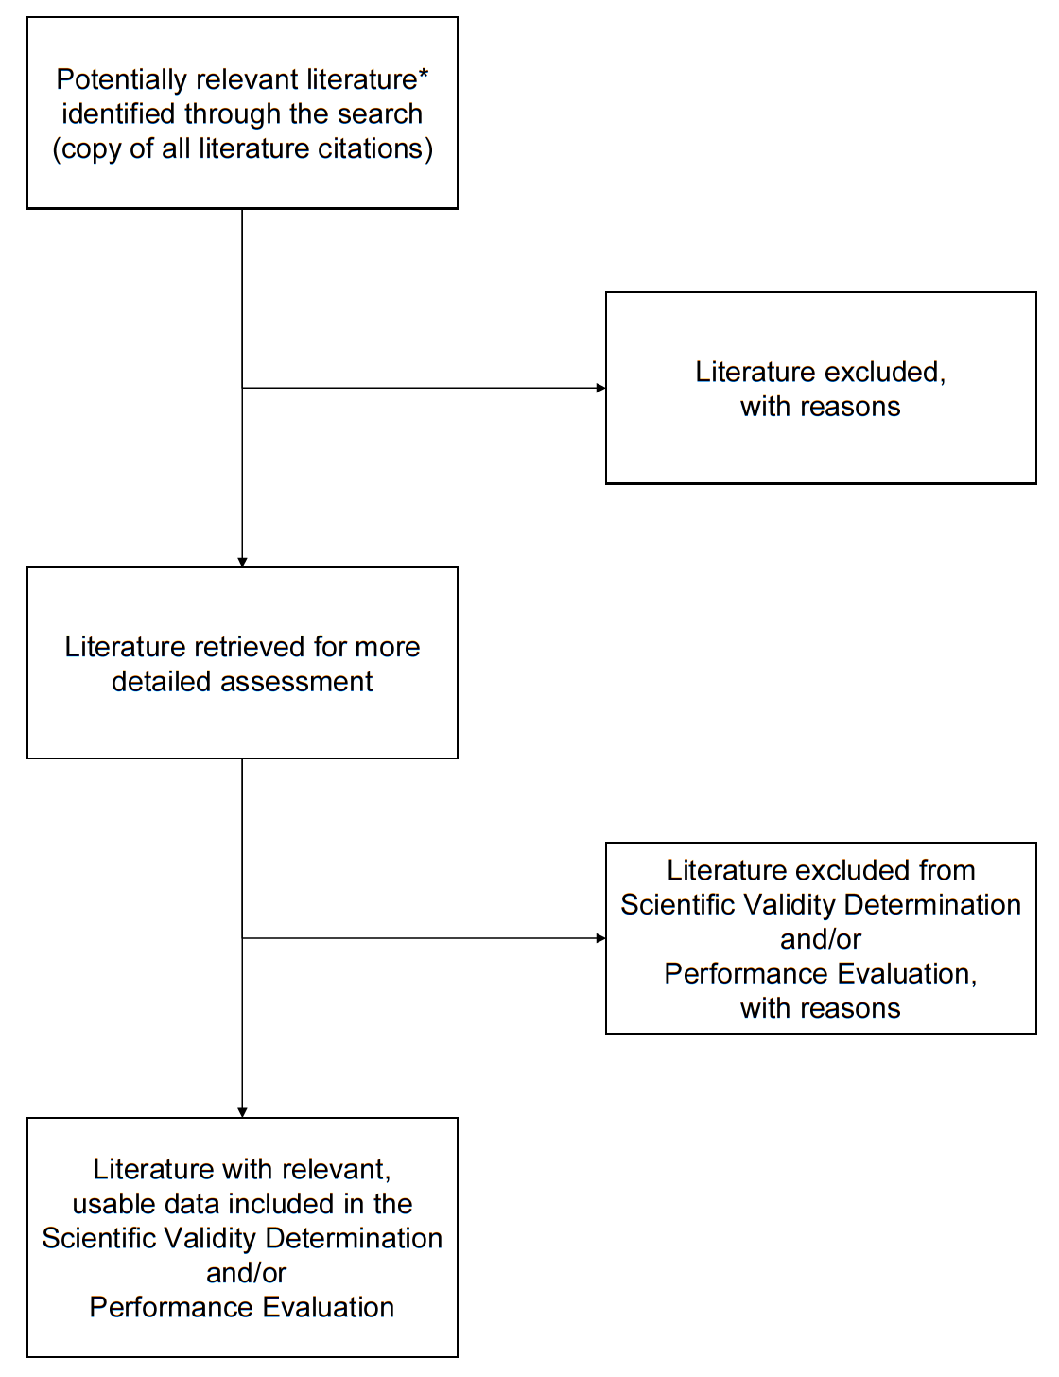
* Some literature for scientific validity may also address clinical performance if the data relates to the manufacturer’s IVD medical device.

Adapted from Moher, D., Cook, D. J., Eastwood, S., Olkin, I., Rennie, D., & Stroup, D. F. Improving the quality of reports of meta-analyses of randomised controlled trials: the QUORUM statement. Quality of Reporting of Metaanalyses. Lancet 1999; 354: 1896-1900.

