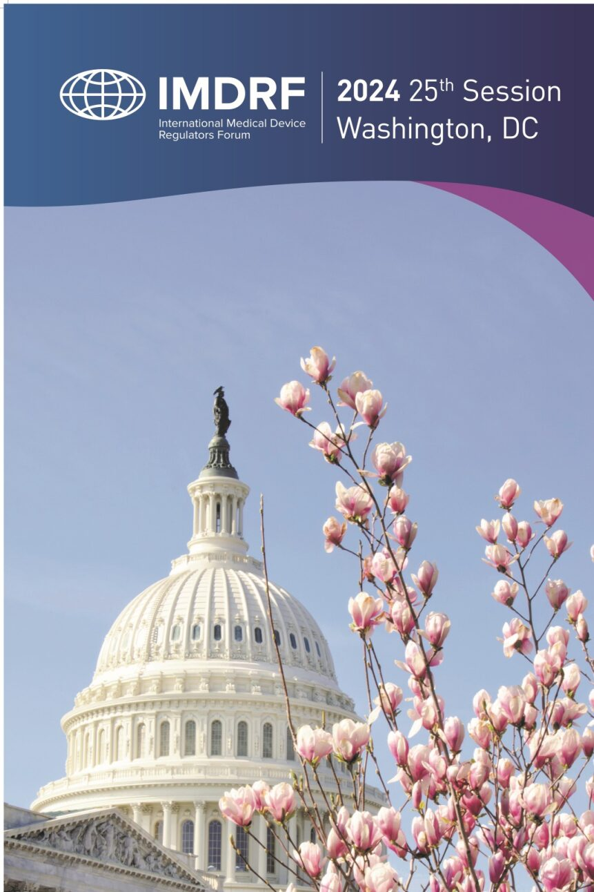

Joint Workshop

between

IMDRF and DITTA and GMTA

Benefits and Opportunities of Medical Device Regulatory Reliance
11 March 2024

White Paper

Medical Device Regulatory Reliance

This White Paper summarizes the discussions and observations arising from the International Medical Device Regulators Forum (IMDRF) 25th Session Joint IMDRF-DITTA and GMTA Workshop on “Reliance.” The workshop was chaired by the United States under its role as the IMDRF Chair for 2024.
The workshop began by defining reliance using WHO’s Good Reliance Practices document and noting that not all approaches to regulatory reliance are identical. As evidenced by the many case studies and perspectives shared throughout the workshop, reliance may be adapted by each regulator to serve their own jurisdictional needs. Both regulators and industry representatives noted the many benefits of reliance, including faster patient access to safe, effective, high-quality, innovative medical devices, quicker identification of postmarket issues, and the ability to reallocate resources to other activities.
IMDRF has already played and will continue to play a critical role in bringing regulators together, building trust and driving the convergence of approaches needed to support regulatory reliance in practice.

Session 1- Reliance in a Premarket Setting
During this session, speakers shared their experiences and challenges navigating and administering reliance models in a premarket setting. Regulators discussed the importance of maintaining their own decision-making authority and described the processes used to develop, implement, and improve upon reliance frameworks. Trust and communication among regulators as well as the need for clarity and transparency in decision-making are critical to successful implementation of reliance.
Specific case studies (e.g., blood screening test) illustrated the value of reliance in getting devices to patients quicker and the need for clear communication and discussion between industry and regulators when piloting new approaches. Regulators noted that implementing reliance enabled a shifting of resources within their organizations. For example, some regulators reallocated resources from premarket reviews and assessments to postmarket activities or innovative technologies (e.g., digital health) once reliance models were fully implemented.
All speakers noted that convergence on regulatory requirements and approaches is often a first step towards reliance. Reliance is easier when the approach to regulation is already similar between regulators. To that end, IMDRF’s harmonized technical documents (e.g., those from the Good Regulatory Review Practices and Regulated Product Submission working groups) provide a particularly valuable starting point for discussions about premarket reliance among regulators. In addition, the engagement of regulators in the development of internationally harmonized standards as well as the use of these standards, with as few jurisdiction-specific deviations as possible, is foundational to reliance in a premarket setting.

Observations:
- Reliance in a premarket setting speeds access of safe, effective, high-quality, innovative medical devices to patients.
- Reliance allows for knowledge sharing among regulatory authorities and reallocation of resources within a given regulatory authority without a decrease in regulatory requirements.
- Regulatory authorities can maintain sovereignty and their own decision-making authority when implementing reliance.
- Trust and communications among regulatory authorities relying on one another is critical to successful implementation of reliance.
- Convergence and harmonization are often a first step towards reliance; regulatory authorities with similar approaches are better able to leverage the decisions of one another.

Session 2- Reliance in a Postmarket Setting
This session focused on reliance in a postmarket setting. Speakers observed that, while reliance is often discussed in the context of premarket decision-making, the opportunities for and benefits of reliance are equally valuable in the areas of postmarket surveillance and assessments of manufacturers’ quality systems.
Exchange of information among regulators regarding adverse events, field safety corrective actions, and other postmarket surveillance activities allows for early identification and communication of issues impacting patient safety. Many regulators already work together in detection and analysis of potential concerns. For example, regulators often refer to and use one another’s public announcements as one of many sources of information when determining whether and what actions to take postmarket. IMDRF/AE WG/N43 (“Terminologies for Categorized Adverse Event Reporting (AER): terms, terminology, and codes”) supports common coding and terminology of adverse events, facilitating clear discussions among regulators and industry that speed identification of issues of public health importance.
As with reliance in a premarket setting, convergence of requirements is a fundamental building block to successful implementation of reliance in a postmarket setting. ISO 13485 serves as the harmonized basis for many regulators’ requirements regarding a manufacturer’s quality system. The Medical Device Single Audit Program (MDSAP) provides a case study of effective reliance among regulators, with several participating regulators noting their ability to confidently reallocate resources to other activities (e.g., establishing postmarket monitoring programs for specific device types or conducting more in-depth follow ups investigations on issues identified during inspections).

Observations:
- Reliance in a postmarket setting allows for quicker identification of and communication about potential patient safety issues as well as significant reallocation of resources required for conducting inspections of manufacturers.
- The use of internationally harmonized standards (e.g., ISO 13485) and IMDRF technical documents (e.g., AET document) provide a valuable starting point of postmarket reliance.
- As with premarket reliance, trust, communication, clarity, and transparency are essential to successful implementation of a reliance model in the postmarket setting.
- The MDSAP provides a case study of reliance for regulatory audits of manufacturers.

Session 3- Next Steps
This session provided an opportunity for panelists to reflect on themes from the previous discussions and propose ideas for how stakeholders can continue to work together to further realize the benefits of reliance.
Panelists noted that while each stakeholder plays a different role, we are all part of the infrastructure to provide safe, effective, high-quality, innovative medical devices to patients as quickly as possible. Reliance is an important tool available to all regulatory authorities and applies equally in premarket and postmarket settings. Reliance supports efficient allocation of resources and swift identification of potential postmarket issues. Reliance can be most effective when regulators not only have access to the same information, but also make aligned decisions as a result of this information.
Regulators with similar approaches to regulation are better able to rely on one another. To this end, convergence of regulatory requirements and approaches, through development of internationally harmonized standards and publication of IMDRF technical documents, is fundamental to supporting reliance. Industry representatives spoke to the burden of jurisdiction-specific requirements in pre- and postmarket settings and the need for a total product lifecycle approach to reliance.
Reliance requires trust between regulators. Working together, within and outside of IMDRF, strengthens the relationships among stakeholders and builds the confidence and credibility necessary to successfully implement reliance.
Regulators identified challenges in implementing reliance in their jurisdictions. For example, stakeholders may have concerns if they do not understand that a regulator’s authority and sovereignty is maintained in a reliance model. In addition, regulators play an important role in supporting local manufacturing, which some stakeholders may view as in conflict with a reliance model.

Observations:
- IMDRF plays a critical role in bringing stakeholders together to share experiences and build trust.
- Future work for IMDRF to further reliance could include:
  - Publication of a reliance playbook with information on how to implement reliance;
  - Identification of which regulators within IMDRF have implemented reliance practices; and
  - Providing training to support adoption of IMDRF technical documents and convergence of regulatory requirements.

