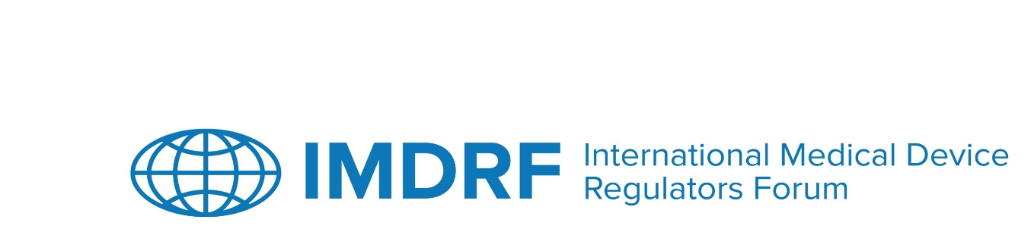

OUTCOME STATEMENT
IMDRF 22nd Management Committee Meeting
12 to 16 September 2022
Sydney, Australia
The 22nd meeting of the Management Committee (MC) of the International Medical Device Regulators Forum (IMDRF) and Official Observers took place both in-person in Sydney, Australia, and on-line from 12 to 16 September 2022. The meeting was chaired by Australia.
Joint IMDRF / DITTA Workshop – Standards for Health Software
On 12 September 2022, the IMDRF / DITTA Joint Workshop on Standards for Health Software, Improving Quality for Regulatory Use was held. Over 200 stakeholders joined virtually and more than 100 participants attended in person. Regulators, industry representatives and standard organisation representatives shared their experience and challenges with the existing standards (horizontal and vertical) as well as the speed of reviewing or developing new standards, and the need for state-of-the-art technology evaluation processes. There were discussions on health software versus medical device software and that some software developers are new to medical device regulations. Participants also discussed transparency, governance and the need for a common understanding of terms. The panellists exchanged views on the appropriateness of specific standards that support medical device life cycle approaches.
Joint IMDRF / GMTA Workshop – Artificial Intelligence in Medical Devices
On 12 September 2022, the IMDRF / GMTA Joint Workshop focussed on Updates and Considerations for Artificial Intelligence (AI) and Medical Devices. Over 200 stakeholders joined virtually and 100 participants attending in person. Regulators, industry representatives and researchers shared their experience and perspectives on the current and emerging AI and medical device technologies and products. There was a recognition of the growing use of AI in clinical settings and trends emerging such as cloud use, integration between hardware and software and AI underpinning population health management and precision pathology. The panellists exchanged views on the benefits and risks, challenges, and potential regulatory approaches for these technologies during the panel discussion. There was a recognition that some stakeholders may not appreciate the limitations of AI, unintended bias’s and therefore, the importance of the IMDRF AIMD WG was noted.
IMDRF Stakeholder Open Forum
On Tuesday 13 September 2022, the IMDRF Open Stakeholder Forum was held with over 200 stakeholders joined virtually and 100 participants attending in person. Attendees were representatives of regulatory authorities, industry and the research community.

Regulatory updates were provided by MC Members and Official Observers and representatives of seven of the IMDRF’s Working Groups:

- Medical Device Cybersecurity Guide – Canada
- Regulated Product Submission – Canada
- Software as a Medical Device – Canada
- Artificial Intelligence Medical Devices – South Korea
- Personalized Medical Devices – Australia
- Medical Device Adverse Event Terminology – USA
- Good Regulatory Review Practice – USA

Presentation materials were also provided to update on the work of:
- APEC LSIF Regulatory Harmonization Steering Committee (RHSC)
- Global Harmonization Working Party (GHWP)
- Pan American Health Organization (PAHO)
- African Medical Devices Forum (AMDF)
- SwissMedic
- Global Diagnostic Imaging, Healthcare IT & Radiation Therapy Trade Association (DITTA)
- Global Medical Technology Alliance (GMTA)
- ASTM International
All presentation materials for the IMDRF / DITTA and IMDRF / GMTA workshops as well as the IMDRF Stakeholder Open Forum are available on the IMDRF Website.
Open MC Session
On Wednesday, 14 September 2022, the MC Open Session was held providing an opportunity for Regional Harmonization Initiatives, Invited Observers and the GMTA and DITTA to update and engage with the MC including:
- African Medical Devices Forum
- Swissmedic
- GHWP
- DITTA
- GMTA
- Center for State Control of Medicines and Medical Devices (CECMED), Cuba
- National Institute of Drug and Food Surveillance (INVIMA), Columbia
- The Federal Commission for Protection against Health Risks (COFEPRIS), Mexico
- Asia Pacific Medical Technology Association (APACMed)
- Israel Ministry of Health
- South African Health Products Regulatory Authority (SAHPRA)

Closed MC Session
The MC Closed Session was held over two days, 15 and 16 September 2022. The MC discussed and made decisions regarding the documents put forward from current Working Groups, New Work Item Proposals put forward by MC Members, and other procedural matters (See Annex).

ANNEX
DECISIONS BY THE IMDRF MANAGEMENT COMMITTEE

15 and 16 September 2022

Sydney, Australia

In summary:
- The MC agreed that the European Union (Commission) will be the IMDRF Chair and Secretariat in 2023 and agreed a range of procedures to strengthen the IMDRF Chair and Secretariat handover.
- The MC agreed that the IMDRF / Industry workshop, which is scheduled to be held in March 2023, should be on post market related topics.
- The MC agreed that a Quality Management Systems (QMS) Working Group (WG) will be established with the US FDA as the Chair.
- The MC agreed to pause the Clinical Evidence for IVD Medical Devices WG.
- The MC agreed two public consultations for the Personalized Medical Devices (PMD) WG be opened:
  - IMDRF/N58 PMD Regulatory Pathways for 60 days;
  - IMDRF/N74 PMD Production Verification and Validation for 90 days.
- The MC continued the discussions on the Implementation Table (the Table) and agreed that the input from Official Observers who are Regulatory Authorities be included in the Table going forward.
- The MC agreed that they would identify more effective mechanisms for improved collaboration with stakeholder groups.

