IMDRF/AE WG /N44FINAL:2017

FINAL DOCUMENT

Title: Maintenance of IMDRF AE Terminologies

Authoring Group: IMDRF Adverse Event Terminology Working Group

Date: 16 March 2017

Kimby Barton, IMDRF Chair

This document was produced by the International Medical Device Regulators Forum. There are no restrictions on the reproduction or use of this document; however, incorporation of this document, in part or in whole, into another document, or its translation into languages other than English, does not convey or represent an endorsement of any kind by the International Medical Device Regulators Forum.

Copyright © 2017 by the International Medical Device Regulators Forum.

Table of Contents

1.0 Introduction 4
2.0 Scope 4
3.0 Reference 4
4.0 Definition 4
5.0 IMDRF AE Terminologies Maintenance WG 5
6.0 Maintenance Process 5
6.1 Submission of Change Requests 7
6.1.1 How to Submit 7
6.1.2 Request Form 7
6.2 Review and development of recommendation by the AETM WG 8
6.3 MC approval and Public Consultation 8
6.4 Final recommendation 8
6.5 MC approval/IMDRF decision 8
6.6 Documentation of IMDRF decision on webpage 8

Preface

The document herein was produced by the International Medical Device Regulators Forum (IMDRF), a voluntary group of medical device regulators from around the world. The document has been subject to consultation throughout its development.

There are no restrictions on the reproduction, distribution or use of this document; however, incorporation of this document, in part or in whole, into any other document, or its translation into languages other than English, does not convey or represent an endorsement of any kind by the International Medical Device Regulators Forum.

Introduction
The Adverse Event Working Group (“AE WG”) organized under International Medical Device Regulators Forum (“IMDRF”) has developed a harmonized terminology for reporting adverse events (“IMDRF AE Terminology”) that are known or suspected to be linked to the use of medical devices and in vitro diagnostics.

Globally harmonized terminologies for adverse event reporting are a key requirement for more effective reporting, analysis and information exchange of adverse events and will reduce the burden for manufacturers and other reporters (e.g., sponsors).

Once developed and agreed upon, there will be a clear need for an agreed approach for maintenance of these terminologies, ensuring adjustments that may be required over time, especially for;
- technical updates and innovations (e.g., new devices, materials)
- other developing needs of intended users, such as AE reporters and regulatory authorities
The AE WG has considered the options for ongoing maintenance of the IMDRF AE Terminology. This document is intended to describe the basic procedures that should be followed in order to maintain the currency, adequacy, and accuracy of the IMDRF AE Terminology following their initial publication.

Scope
This document sets forth the basic procedures for revising the IMDRF AE terminology described in Annexes A through D of the IMDRF document entitled, “IMDRF terminologies for categorized Adverse Event Reporting (AER): terms, terminology structure and codes (IMDRF/AE WG/N43)”.

Reference
- IMDRF/AE WG/N43 - IMDRF terminologies for categorized Adverse Event Reporting (AER): terms, terminology structure, and codes

Definition
“Member Jurisdiction” shall mean the jurisdiction to which a member of the AE WG belongs.

“National Competent Authority” shall mean any duly authorized regulatory authority affiliated with a national or regional entity, which is tasked with regulating medical devices and in vitro diagnostics in its jurisdiction.

“Stakeholder Organization” shall mean an organization that has any direct or indirect interest in medical devices or in vitro diagnostics (e.g. industry associations, professional associations, professional medical associations, patient associations, etc.).

IMDRF AE Terminologies Maintenance WG
Maintenance of IMDRF AE terminology is conducted by a dedicated IMDRF WG called IMDRF AE Terminology Maintenance Working Group (“AETM WG”). The AETM WG consists of at least one member from each IMDRF Member Jurisdiction and, as appropriate, observers from other jurisdictions.

The AETM WG is chaired by one (1) Member Jurisdiction, on a rotational basis. The chairing jurisdiction also provides a secretariat for handling the request of modification(s) to, deletion(s) from, or addition(s) to the AE Terminologies (“Change Request(s)”) from stakeholders.

The AETM WG has a special webpage (“AETM Webpage”) on the IMDRF website (http://www.imdrf.org/) dedicated for collecting Change Requests.

Maintenance Process
Maintenance of the IMDRF AE Terminology is subject to the approval of the Management Committee (“MC”) of IMDRF, and the maintenance process follows the steps outlined below:

1) Submission of Change Requests
2) Review and development of recommendation to the MC by the AETM WG
3) MC approval and Public Consultation
4) Final recommendation to the MC by the AETM WG
5) MC approval/IMDRF decision
6) Documentation of IMDRF decision on webpage

This process is conducted once per year.

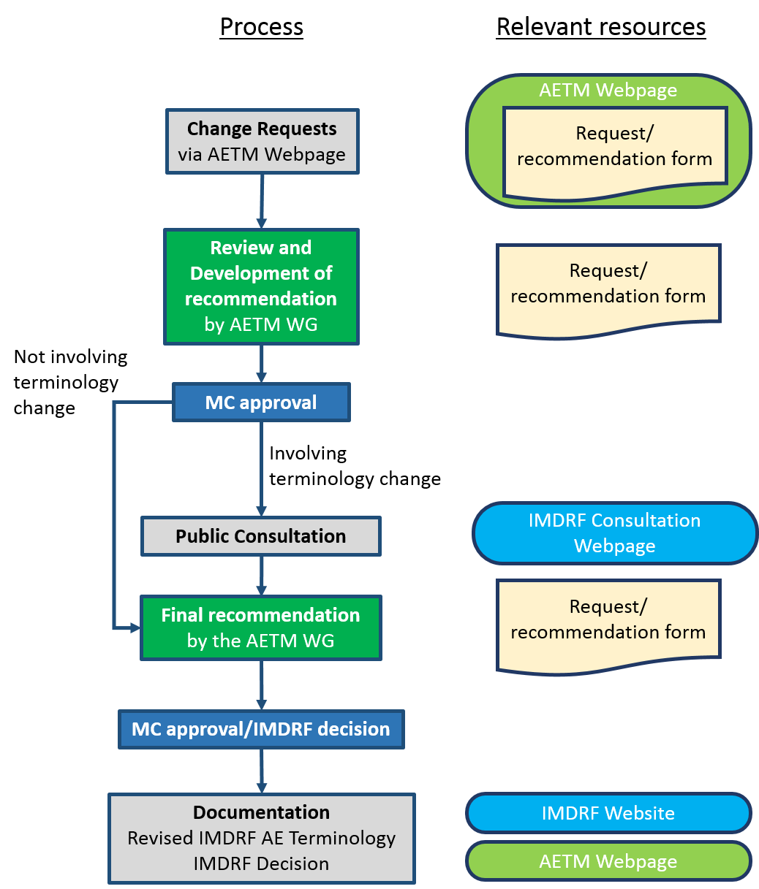

Fig.1: IMDRF AE Terminology maintenance process

Submission of Change Requests

How to Submit
Change Requests may be submitted any time via the AETM Webpage by either 1) National Competent Authorities or 2) Stakeholder Organizations.

As the existing IMDRF AE Terminologies are comprehensive and have gone under public consultations, revisions shall be kept to the minimum necessary to cater for technological and regulatory changes.

Before submitting Change Requests, potential submitters should first consult past IMDRF decision documented in the Change and Request Form posted on the AETM Webpage to ensure that their proposed change(s) were not already addressed (i.e., rejected) in the past. The same request may not be re-submitted unless a substantial and reasonable rationale for doing so is also submitted.

The secretariat shall compile a record of all Change Requests and maintain such record until final decisions are reached.

Request Form
Change Requests shall be submitted by completing the request form available on the AETM Webpage (Appendix A) and sending the completed form to the appropriate address as instructed in the AETM Webpage. Change Requests that do not provide sufficient details will not be considered.

The request form shall include each of the following items:

- Terminology (which of the four annexes is subject to change?)
- Proposed Change
- Category of change (Add, Delete, Modify)
- Code (if the proposed change concerns a deletion or a modification of an existing term)
- Term (provide proposed new or modified term)
- Definition (provide proposed new or modified definition)
- Location in the hierarchy (Level, and parent term as appropriate)
- Impact on other existing terms (Describe the impact on existing terms and definitions. E.g. renaming of higher level terms)
- Rationale for change (adequate description of the proposed change)

Review and development of recommendation by the AETM WG
The AETM WG will conduct detailed reviews of the request primarily via regularly scheduled teleconferences.

The AETM WG shall discuss the relevance of the proposed change and present its recommendations to the MC to be considered for approval.

The recommendations shall be prepared using the template form (Appendix A) which will be published on the AETM Webpage as full record of IMDRF decisions in the final step of this process.

MC approval and Public Consultation
Once the MC approves the proposed recommendations, only those recommendations involving changes to the terminology will be posted on the IMDRF Consultation Webpage for public consultation for 60 days.

Final recommendation
The AETM WG will prepare its final recommendation for the change based on feedback from the MC and/or public consultation for final approval.

MC approval/IMDRF decision
The MC will review the final recommendation at their face-to-face meeting. Once the MC approves the final recommendation it will be advanced as an IMDRF decision.

Documentation of IMDRF decision on webpage
After obtaining final approval for the recommendation from the MC, the AETM WG will revise the IMDRF AE terminology reflecting the IMDRF decision. The revised IMDRF AE terminology will be posted on the IMDRF website.

The revised documents will be designated with the inclusion of the text “(Edition X)” to its document identification code (where “X” represents the number of the current revision). Change history will be recorded accordingly in the guidance document.

In addition, the IMDRF decision will be published on the AETM Webpage in chronological order.

Appendix A: Request and Recommendation Form

